One-Week Mini Bioinformatics Project

Introduction

Purpose
The purpose of this project is to utilize the skills we have accumulated in the past 2 weeks of this course to analyze sequence and gene expression data. By using python .fasta file commands, we can analyze the sequencing for the tumor protein p53 (TP53) gene. Properties we may analyze are the number of sequences in the file, the sequence ID’s, the sequence length, nucleotide counts, GC% calculation, and if the sequence contains any unexpected characters. We can also analyze a GEO gene expression series matrix for a breast cancer gene. In doing so, we can identify the gene and sample ID’s, control and experimental groups, mean and median calculation, and check the quality of the data with the presence of gaps or duplicates. Finally, we can take the summary of the gene expression data and visualize it matplotlib. This can make the data easier to digest and analyze in order to draw interpretations and conclusions from the set.

Datasets and Tools
The first part of the project utilized the tumor protein p53 [ Homo sapiens (human) ] sequencing data. It also makes use of the SeqIO python package to process the .fasta sequencing file.The second and third part of the project uses the GSE42568 series matrix for breast cancer gene expression data. These parts of the project use the pandas package to process and organize the data present in the matrix. It also uses the matplotlib package in order to visualize this data.

Methodology
In order to analyze the TP53 sequencing data, each record in the file was first extracted using SeqIO. The sequence ID and the sequence itself was extracted and saved. Using each sequence, I was then able to calculate the length, nucleotide count, and GC percentage. Before calculating any of these, I was able to check if the sequence contained any unexpected characters. I then put all these values into a pandas dataframe such that it was easier to digest, as shown in Figure 1.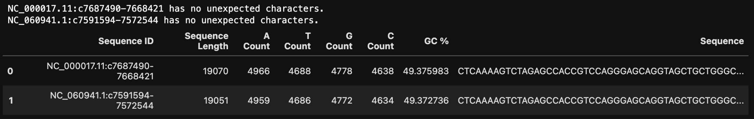
Figure 1

To analyze the GSE42568 series matrix, I first ran some quality checks on the imported excel file such as the shape, the column names, and if there were any duplicates.From there the excel file was first split into the metadata table and the gene expression table. Then, I was able to identify which were control (non-cancerous) samples and which were the experimental (cancerous) samples. I was then able to separate the expression data into the normal and cancerous sample dataframes. From these gene expression tables, the non-cancerous and cancerous expression averages were calculated for each probe and the median expression for each sample.

In the third part of the project, the gene expression data was visualized in 3 different plots. First a bar graph was used to show the difference in expression in the normal groups versus the cancerous groups for each probe. Since this proved to be a convoluted graph, I then isolated genes that seemed to have either a significantly higher normal expression or higher cancerous expression. These graphs are shown in Figure 2 and Figure 3.

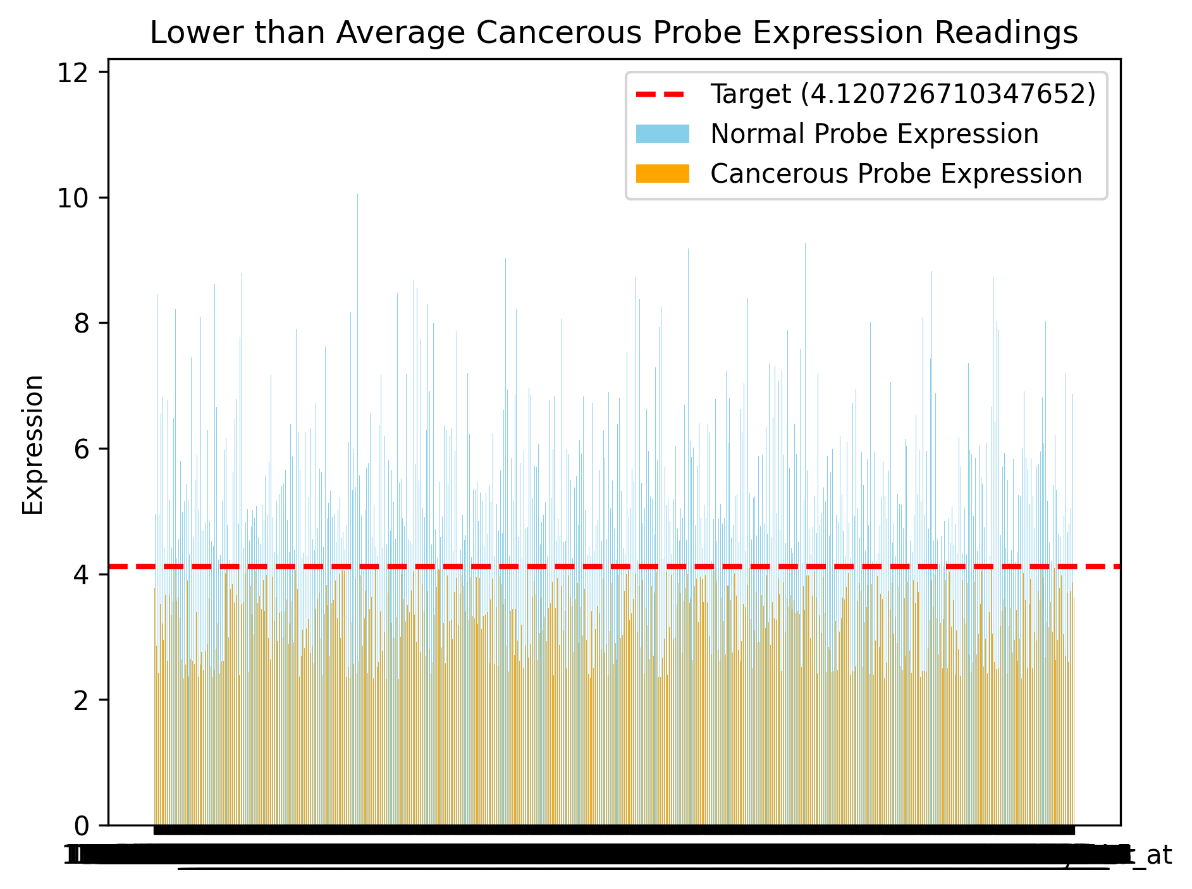
Figure 2
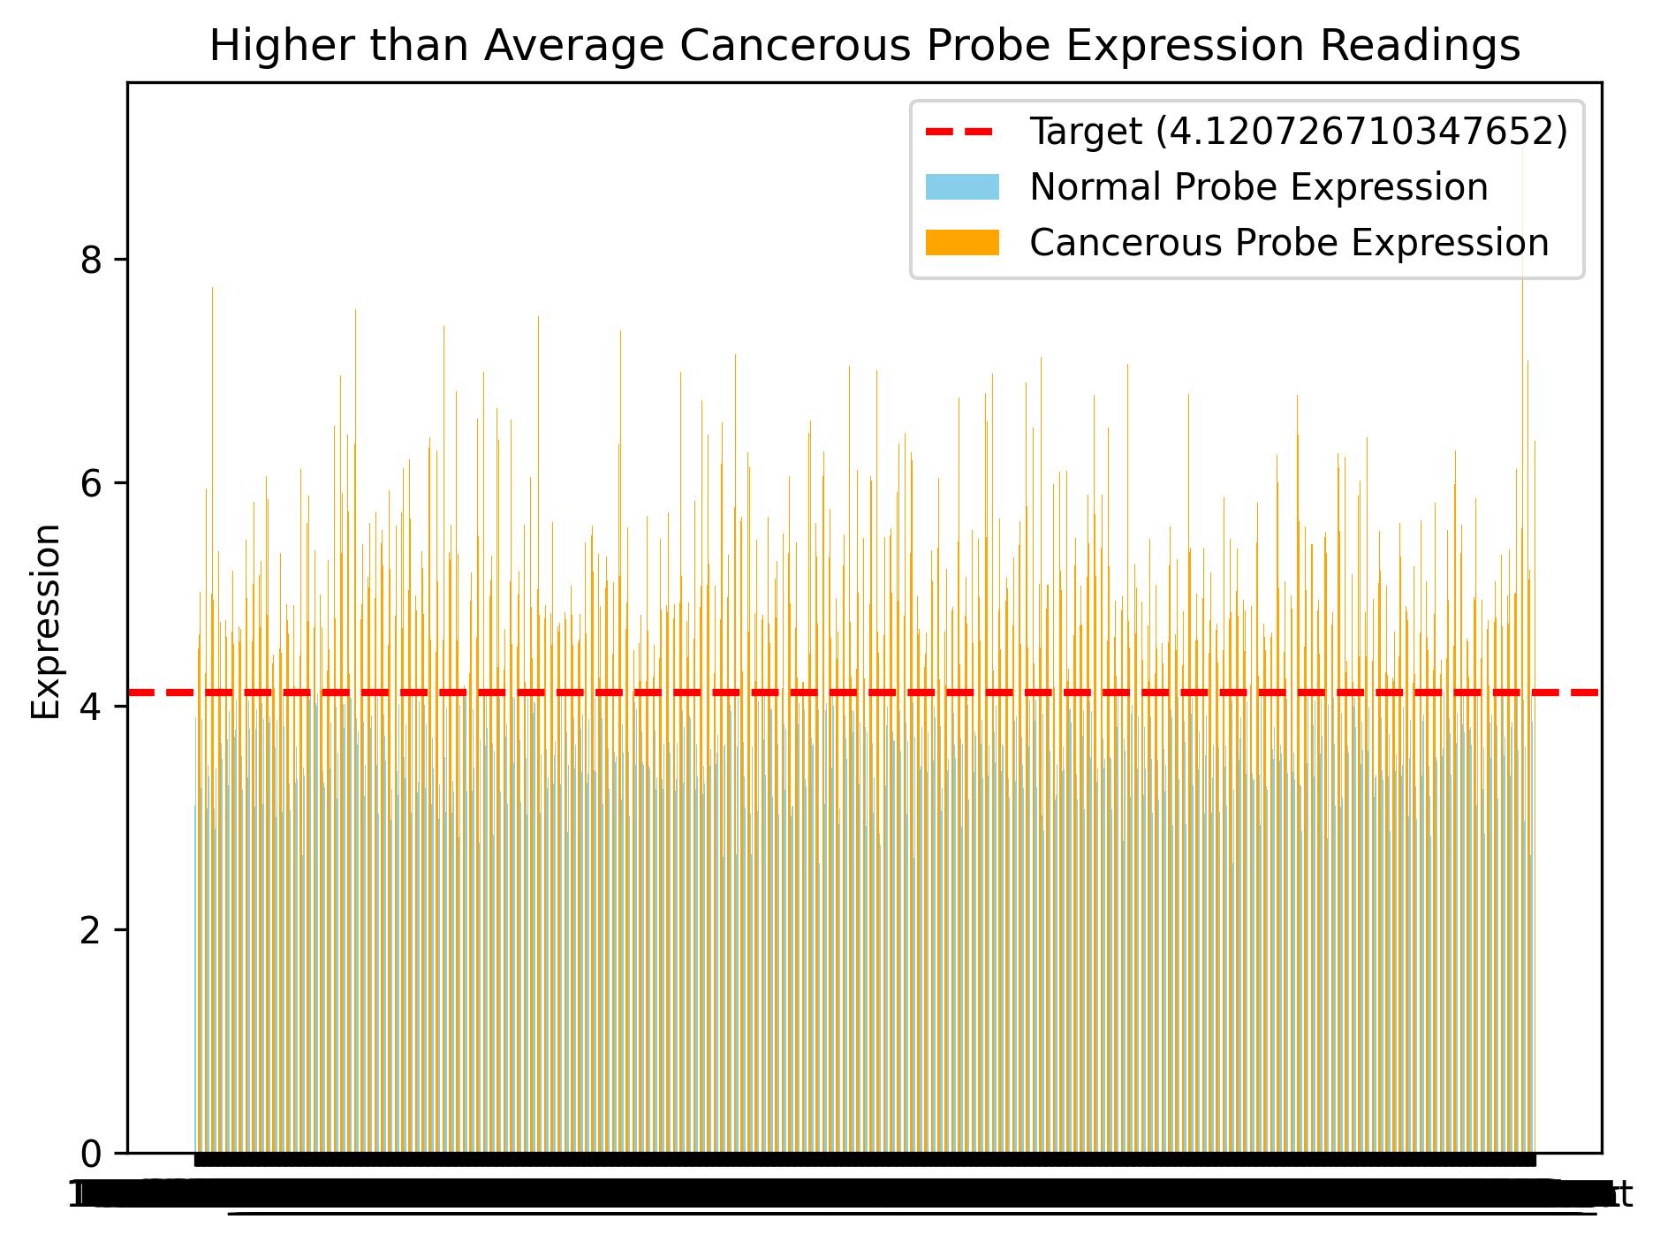
Figure 3

The second graph was a histogram. Again, because this proved to be a convoluted graph, I decided to plot the relative frequency of the expression readings. This graph was also separated by normal versus cancerous samples and can be seen in Figure 4.
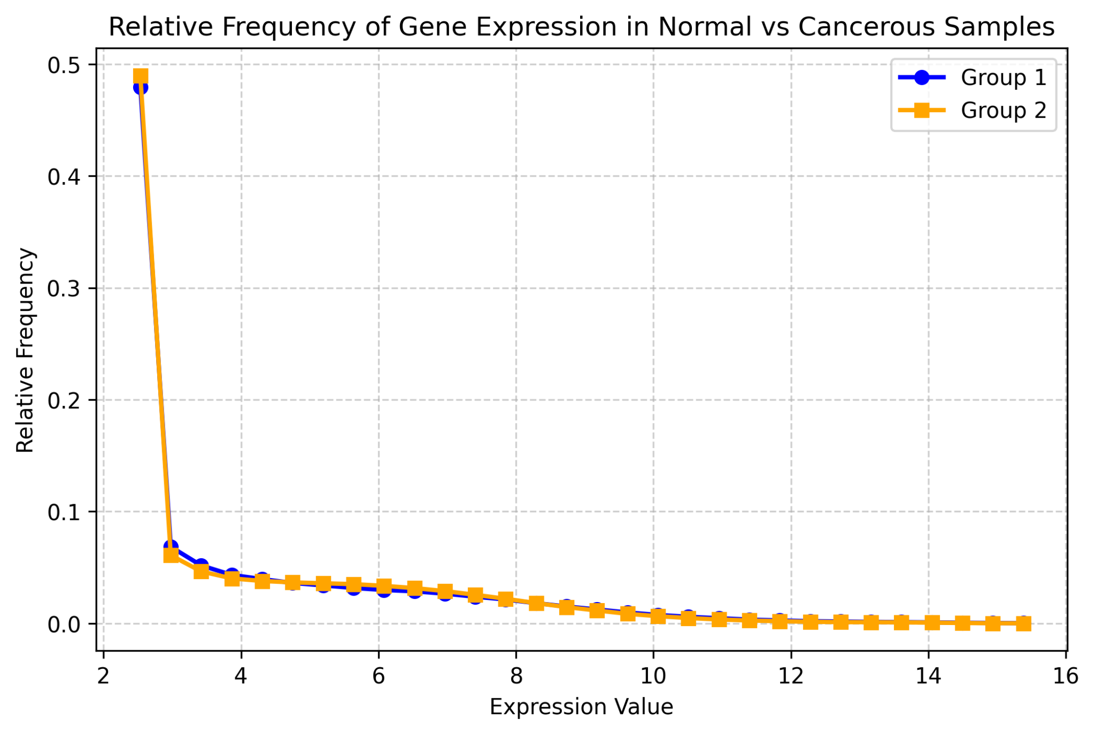
Figure 4

The third plot was a box plot. In order to get a holistic view of the data, I plotted the medians for each sample that was previously calculated. The samples were again separated into the control and experimental groups and can be seen in Figure 5.
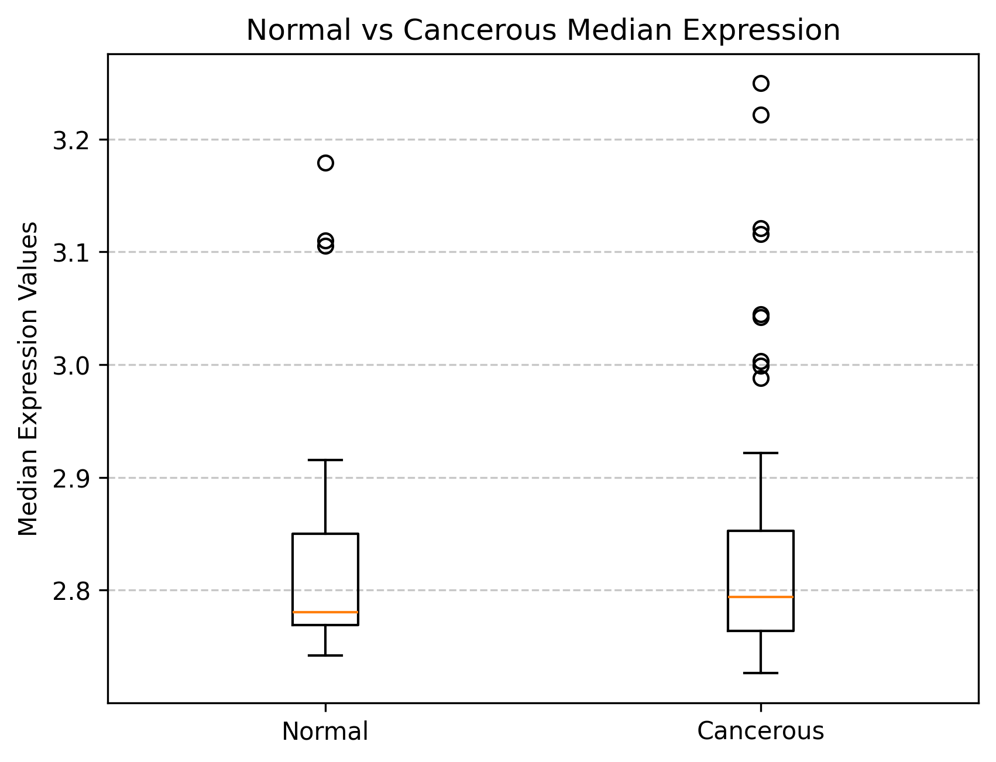
Figure 5

Interpretation
Looking at Figure 1, we can conclude that the TP53 sequencing data contained two different sequences. Both sequences contained no unexpected characters. The sequences also both had around 49% for the GC percentage.

Looking at Figures 2 and 3, we can compare how many genes have higher expression in the normal samples versus the cancerous samples. Upon analysis, there are more genes that have a higher than average gene expression in the cancerous samples, however this is likely due to there being more cancerous samples than normal samples. By looking at Figure 4, we can draw the conclusion that most expression readings fall within the 2-4 range. This conclusion is also supported by Figure 5 as most of the density of data for both groups lie within the 2.5-3 range.

